**Algorithmic Trading**

**Introduction:-**

Execution of trades on stock exchanges based on predefined criteria and without any human intervention using computer programs and software is called algorithmic trading or algo trading. While being a subset of [algorithmic trading](https://blog.quantinsti.com/algorithmic-trading/), high-frequency trading involves buying and selling thousands of shares in fractions of seconds. In the US and other developed markets, High-Frequency Trading and Algorithmic trading accounts for an estimated 70% of equities market share. In India, the percentage with respect to the [total turnover](https://www.financialexpress.com/market/algorithmic-trading-share-in-total-turnover-grows-to-50-in-8-years/1159020/) has increased up to 49.8%.

On April 3rd 2008, Securities & Exchange Board of India (SEBI), introduced algorithmic trading by allowing Direct Market Access facility to institutional clients. In short, DMA allows brokers to provide their infrastructure to clients and gives them access to the exchange trading system without any intervention from their part. Initially, it was provided only to institutional clients and not retail traders.

**Advantages:-**

One of the big reasons that algorithmic trading has become so popular is because of the advantages that it holds over trading manually. The advantages of algorithmic trading are related to speed, accuracy, and reduced costs.

* Since algorithms are written beforehand and are executed automatically, the main advantage is speed. The speed at which these trades are made is measured in fractions of a second, faster than humans can perceive.
* Trading with algorithms has the advantage of scanning and executing on multiple indicators at a speed that no human could do. Since trades can be analyzed and executed faster, more opportunities are available at better prices.
* Another advantage to algorithmic trading is accuracy. If a computer is automatically executing a trade, you get to avoid the pitfalls of accidentally putting in the wrong trade associated with human trades. With manual entries, it's much more likely to buy the wrong currency pair, or for the wrong amount, compared to a computer algorithm that has been double checked to make sure the correct order is entered.
* One of the biggest advantages of algorithmic trading is the ability to remove human emotion from the markets, as trades are constrained within a set of predefined criteria. Why this is an advantage is because humans trading are susceptible to emotions that lead to irrational decisions. The two emotions that lead to poor decisions that algorithmic traders aren't susceptible to are fear, and greed.
* Another advantage to algorithmic trading is the ability to backtest. It can be tough for traders to know what parts of their trading system work and what doesn't work since they can't run their system on past data. With algorithmic trading, you can run the algorithms based on past data to see if it would have worked in the past. This ability provides a huge advantage as it lets the user remove any flaws of a trading system before you run it live.

**Basic Architecture of Algorithmic Trading:**

A traditional trading system consists primarily of two blocks – one that receives the market data while the other that sends the order request to the exchange. However, an algorithmic trading system can be broken down into three parts:

* Exchange
* The server
* Application

Exchange provide data to the system, which typically consists of the latest order book, traded volumes, and last traded price of script. The server in turn receives the data simultaneously acting as a store for historical database. The data is analyzed at the application side, where trading strategies are fed from the user and can be viewed on the GUI. Once the order is generated, it is sent to the Order Management System (OMS), which in turn transmits it to the exchange.

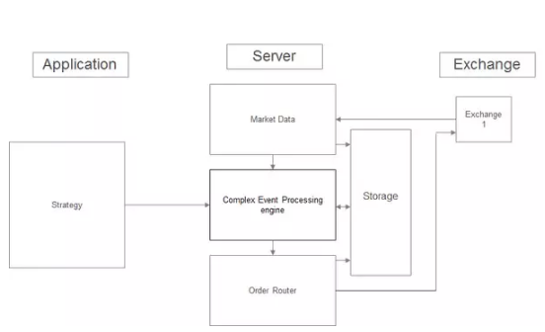

**How to become Algorithmic Trader?**

If you want to become an algorithmic trader then you should have expertise in three fields which are listed below.

* Quantitive Analysis
* Programming
* Trading (Financial Market Knowledge)

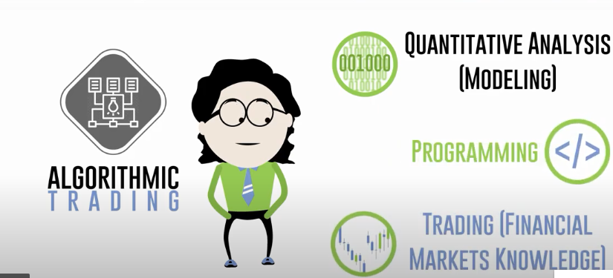

Apart from trading skills you will also need

* Trading Strategy :- Trading Strategy will be useful for Quantitive Analysis.
* Trading Software:- It will be useful for connecting to exchange and execute trade for you.
* Live Data: -It will be useful for trading.
* Historical Data: -It will be useful for testing your strategy.
* And also for obvious reason you will need servers, Backup Power supply and Internet Connection.

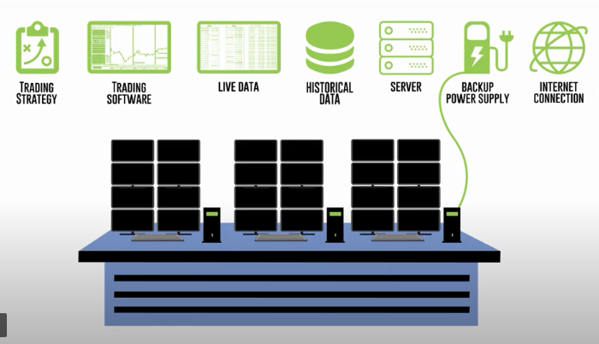

**Platforms For Algorithmic Trading:-**

Multiple algo-trading strategies are used by the traders to create algorithms that are efficient enough to earn profits by the process of either following trends or arbitrage or trend reversals. Since algo trading makes use of advanced technology for its smooth functioning, it is imperative to use the algo trading platforms and tools that make the process efficient.

The algo trading platforms, tools and software must be sophisticated, fast, easily accessible and state-of-the-art .The entire premise of algo trading lies in the speed and the accuracy with the trades get executed. Below are the recommendations. They are not in any particular order. And some of these apply to global exchanges as well and not just Indian exchanges.

* Tradetron
* Zerodha Streak
* Symphony BlitzTrader
* Robotrader
* SquareOff

**Some of tools for Algorithmic Trading.**

Python is most preferred language in Algorithmic Trading.

NSE offers the algorithmic trading results using Python and by utilizing different apps and software available.

* Python Trading Library for Technical Analysis

### **TA-Lib**

## **Python Trading Libraries for Data Manipulations**

### **NumPy**

* + Pandas
  + Scipy

## **Python Trading Library for Plotting Structures**

### **Matplotlib**

## **Python Trading Libraries for Machine Learning**

### **Scikit-learn**

* + Tensorflow
  + Keras

## **Python Trading Libraries for Backtesting**

### **PyAlgoTrade**

### **Zipline (Used by Quantopian)**

### **Pybacktest**

## **Python Trading Libraries for Data Collection**

### **Ultrafinance**

### **TWP (Trading With Python)**

### **Trading on Interactive Brokers using Python**

### **IBridgePy**

### **IBPy**

## **Open Source Python Trading Platforms**

### **Blueshift**

### **Quantiacs**

### **Quantopian**

**A Preliminary analysis for building a cloud based stock analysis/operations tool.**

For Building your own Stock analysis operation application you will need to have various tools for it like programming languages, API etc some of the tools are listed below.

Programming languages:- Programming languages like Python and C++ are very useful for doing analysis on stock . Many stock analysis software uses python for stock analysis because it supports various frameworks for stock analysis which proves very helpful for doing stock analysis.

API :- You will have to make use of API for getting data form BSE or NSE . There are multiple data vendors available which offer data for NSE FNO, NSE Currency etc. some of these are

1. Global data feeds - Cost around 2000/month for physical machine and 22000/year for virtual machine  
2. Neo-Trade Analytics - Cost around 1200/month for both physical and virtual machine

Frameworks:- Frameworks will be useful for accessing and visualizing the data some of best frame works are matplotlib, Numpy and pandas

**AI and algorithmic trading in the real world.**

AI is not just something that’s being talked about. It’s already here and changing the financial world significantly, especially when it comes to trading practices. Top financial institutions including UBS and JP Morgan have already introduced AI into their trading tools with the former using AI techniques to trade volatility and the latter using AI algorithms to execute equity trades. Algorithms enhanced by AI are also being used to guide venture capitalist investments.

AI is being increasingly utilised in the algorithmic trading sector and offers many benefits. As 80% of all data is completely unstructured, AI and its complexed applications including ML and DL aims to deliver a more structured, organised and data-fuelled approach to the trading world, helping to make the whole process efficient, while providing split-second insights.

As of May 15th, 2018,” I Know First ” finished the implementation and the training period of its AI-based ranking and forecasting model for the main equities listed on the National Stock Exchange (NSE) of India, specifically a selection of 366 equally-weighted stocks. On this date,” I Know first ” published the first Indian stock forecast for the subscribed investors in the local Indian market, as the timing of the data feed and the forecast generation was adjusted to the respective time zone

References:-

* <https://www.investopedia.com/terms/a/algorithmictrading.asp#:~:text=Algorithmic%20trading%20is%20a%20process,to%20the%20market%20over%20time>.
* <https://blog.quantinsti.com/history-algorithmic-trading-hft/#:~:text=The%20Start%20of%20Algorithmic%20Trading,the%20late%201980s%20and%201990s.&text=Till%201998%20U.S%20Securities%20and,for%20computerized%20High%20Frequency%20Trading>.
* <https://algorithmictrading.net/history-of-algorithmic-trading/>
* <https://www.nasdaq.com/articles/advantages-algorithmic-trading-2019-06-07>
* <https://www.quora.com/How-does-an-algorithmic-trading-system-architecture-look-like>
* <https://www.adigitalblogger.com/algo-trading/algo-trading-platforms/>
* <https://blog.quantinsti.com/python-trading-library/>
* <https://www.investopedia.com/terms/a/application-programming-interface.asp>
* <https://www.moneycontrol.com/news/business/markets/algo-trading-here-are-five-steps-to-set-up-your-own-algorithm-3778381.html>
* <https://www.nasdaq.com/articles/requirements-algorithmic-trading-2019-06-07>
* <https://iknowfirst.com/launch-know-firsts-ai-predictive-system-indian-stock-market-beating-the-nse-benchmark>
* <https://www.adigitalblogger.com/algo-trading/algo-trading-nse/>